HILLY FIELDS FOOTBALL CLUB
SEASON 29: 1995-96
Beckenham Hospital Veterans Cup
P W D L F A
1 0 0 1 2 6
Friendly 27 9 9 9 63 74
TOTAL 28 9 9 10 65 80

Apps Gls Apps Gls
Irving Bartlett 2 0 Shaun Litchfield 3 0
Adrian Bennett 10 0 Kevin Marchant 15 0
Mark Cooper 12 1 Ray Marchant 5 0
Alan Davies 0 0 Kevin McCormick 1 0
Stuart Dyke 3 0 Steve Morton 15 6
Terry Dyke 18 3 Richard Patterson 13 4
Barry Fitzsimmons 1 0 Steve Quinn 12 6
Keith Foster 15 0 Mick Spicknell 6 4
Len Franklin 15 0 Ralph Stanton 0 0
Ian Graver 7 0 Albert St Clair 9 5
Howard Jones 12 5 Dick Stone 5 0
Mark Kellaway 1 0 Dave Wright 14 0
John Kennedy 0 0 Chris Yusuf 7 1
Mike Lane 16 0 OG 3
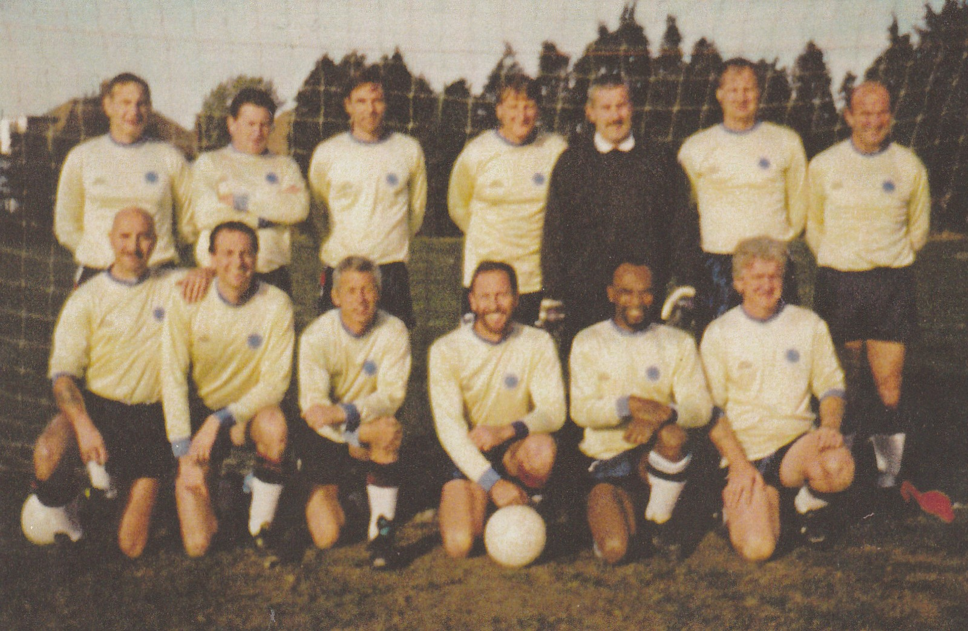
L-R Back: Keith Foster, Len Franklin, Howard Jones, Kevin Marchant, Terry Dyke, Richard Patterson, Adrian Bennett.
L-R Front: Mike Lane, Mick Spicknell, Dave Wright, Steve Morton, Albert St Clair, Steve Quinn

